Hoysaleshwara temple
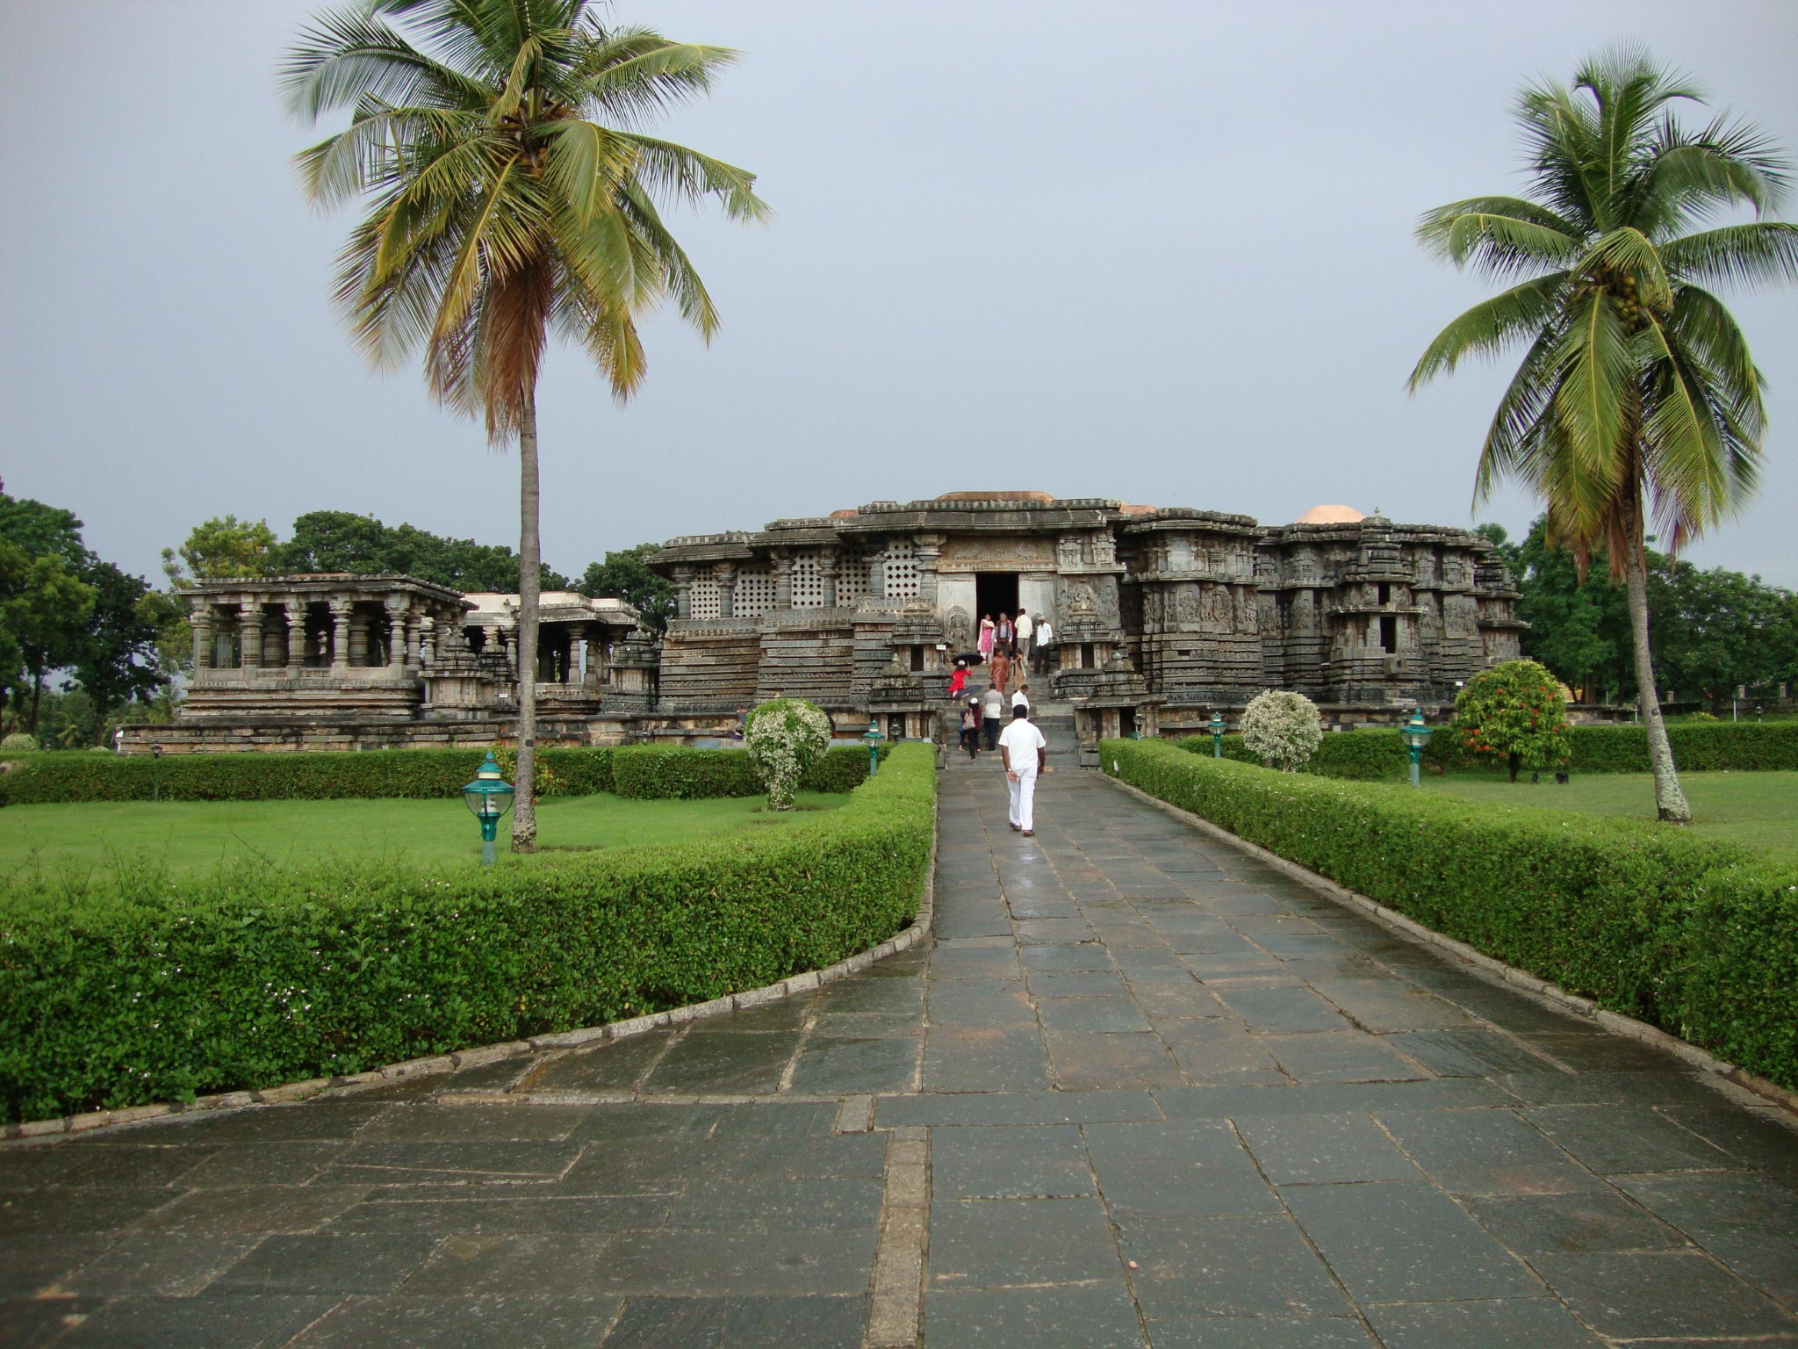
Hoysaleshwara temple (also spelled as Hoysaleswara, Hoysaleśvara or Hoywalesvara temple), also referred simply as the Halebidu temple, is a 12th-century Hindu temple dedicated to the god Shiva. It is the largest monument in Halebidu, a town in the state of Karnataka, India, and the former capital of the Hoysala Empire. The temple was built on the banks of a large man-made lake, and sponsored by King Vishnuvardhana of the Hoysala Empire.Its construction started around 1121 CE and was complete in 1160 CE.
During the early 14th century, Halebidu was twice sacked and plundered by the Muslim armies of the Delhi Sultanate from northern India,and the temple and the capital fell into a state of ruin and neglect. It is 30 kilometres (19 mi) from Hassan city and about 210 kilometres (130 mi) from Bengaluru.The Hoysaleswara temple is a Shaiva monument, yet reverentially includes many themes from Vaishnavism and Shaktism tradition of Hinduism, as well as images from Jainism.
The Hoysaleswara temple is a twin-temple dedicated to Hoysaleswara and Santaleswara Shiva lingas, named after the masculine and feminine aspects, both equal and joined at their transept. It has two Nandi shrines outside, where each seated Nandi face the respective Shiva linga inside.The temple includes a smaller sanctum for the Hindu Sun god Surya. It once had superstructure towers, but no longer and the temple looks flat.The temple faces east, though the monument is presently visited from the north side. Both the main temples and the Nandi shrines are based on a square plan. The temple was carved from soapstone.
It is notable for its sculptures, intricate reliefs, detailed friezes as well its history, iconography, inscriptions in North Indian and South Indian scripts. The temple artwork provides a pictorial window into the life and culture in the 12th century South India. About 340 large reliefs depict the Hindu theology and associated legends.Numerous smaller friezes narrate Hindu texts such as the Ramayana, the Mahabharata and the Bhagavata Purana. Some friezes below large reliefs portray its narrative episodes.
The artwork in Hoysaleswara temple is damaged but largely intact. Within a few kilometers of the temple are numerous ruins of Hoysala architecture, including the Jain Basadi complex and the Kedareshwara temple.
The Hoysaleswara Temple, along with the nearby Chennakeshava Temple at Belur and the Keshava Temple at Somanathapura was declared a World Heritage Site by UNESCO in 2023 as part of the Sacred Ensembles of the Hoysalas.
History
The Hoysala period of South Indian history began about 1000 CE and continued through 1346 CE. In this period, they built around 1,500 temples in 958 centres. Halebidu was originally called Dorasamudra in its inscriptions, possibly derived from Dvarasamudra (Sanskrit words "Dvara" (gateway, door) and Samudra (ocean, sea, large water body)). The capital used to be Belur, Karnataka, but Dorasamudra became the established capital under king Vishnuvardhana and served as the capital of the Hoyasala Empire for nearly 300 years.
Unlike other Hoysala temples that have survived into the modern age, and despite numerous inscriptions in the temple premises, the Hoysaleswara Temple lacks a dedication inscription. It is likely lost, along with the many other features of the original temple. An inscription found about five kilometers from the temple site, near the Kallesvara temple ruins in Ghattadahalli, states that Ketamalla – officer in the employ of king Vishnuvardhana constructed this temple. It also notes that the king made grant of lands to support the construction, the operation and the maintenance of the Shiva temple in Saka 1043, or 1121 CE. It was not the only temple built in that era. The inscriptions suggest that the capital consisted of numerous other temples, both of Hinduism and Jainism traditions, along with stepwells, ponds and mantapas (mandapas, public halls) in the vicinity of the large Dorasamudhra lake.It is the largest temple built by the Hoysalas that is dedicated to the Hindu god Shiva in South India.
The Hoysala Empire and its capital Dorasamudra was invaded, plundered and destroyed in early 14th century by the Delhi Sultanate armies of Alauddin Khilji,with Belur and Halebidu becoming the target of plunder and destruction in 1326 CE by another Delhi Sultanate army of Sultan Muhammad bin Tughlaq. The territory was taken over by the Vijayanagara Empire.The Hoysala kingdom, states James C. Harle, came to an end in mid 14th century, when King Ballala III was killed in a war with the Muslim army of Madurai Sultanate.Dorasamudra and its temples became ruins, the capital abandoned and the site became known as "Halebidu" (literally, "old camp or capital").About 300 of the original Hoysala Empire temples survive in different states of damage, scattered around Karnataka. Of these, states Hardy, about 70 had been studied to varying degrees of detail by 1995.
With the defeat of Tipu Sultan in 1799, Mysore came under the influence of the colonial British rule and scholarship. The Hoysaleswara temple ruins were among the earliest surveyed,then earliest photographed in the 1850s,and the subject of several rounds of good will repairs and restoration that lacked thorough documentation. Ruin panels from other temples were reused here to cover the Nandi mandapa, parts of friezes used to repair the plinth. Thus, the Hoysaleswara temple as it is survives in the contemporary era is a composite of the original Hindu temple architecture and design that was open, to which stone screens with outer walls and doors were added by the 14th-century, whose crowning towers (shikhara) have been lost, and whose ruins were repaired and restored many times in the 19th and 20th-century.
Description
The Hoysaleswara temple is a twin-temple, or dvikuta vimana (plan with two shrines and two superstructures). The two temples are of the same size, and their sanctums open to the east, facing sunrise. The sanctum of the "Hoysaleswara" (the king) and the other for "Shantaleswara" (the queen, Shantala Devi) both have a Shiva linga. Outside on the east side of the main temples are two smaller shrines, each with seated Nandi.To the east of the southern Nandi shrine is a smaller attached Surya shrine, where there is a 7 feet (2.1 m) tall Surya statue facing the Nandi and the sanctum. Historians such as Adam Hardy state that the Hoysaleswara temple shows evidence of other shrines but these are now missing, lost to history.
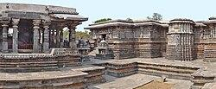
A Nandi shrine (left) facing the sanctum of the main temple
The temple complex as a whole is placed on a jagati (literally, worldly platform). The platform is 15 feet wide around the outer walls of the temple, meant for the visitor to walk on and view the artwork clockwise while completing the circumambulation of the sanctums. It is called the pradakshina-patha (path for circumambulation).The smaller shrines share the same jagati as the main temple, connected by stone stairs. The two sanctums are next to each other in a north–south alignment, both face east, and each have in front a mandapa (also spelled mantapa, community hall). The two mandapas are connected giving a view of a large, open navaranga for family and public gatherings.

North Nandi shrine
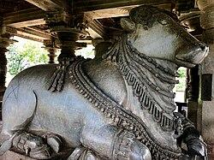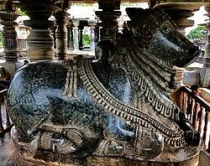
South Nandi shrine
The temple had towers on top of each sanctum, but they are now missing. According to Foekema, these towers must have followed the star shape of the shrine, because Hoyasala temples that are better preserved have them.The superstructure over the vestibule which connects the shrine to the mantapa, called sukanasi (a low tower that looks like an extension of the main tower) is also missing. Similar the row of decorated miniature roofs, the eastern perimeter walls and other shrines with the main temple are all gone.
The temple was built with chloritic schist, more commonly known as greenschist or soapstone.The soapstone is soft when quarried and easier to carve into intricate shapes, but hardens over time when exposed to air.
Outer walls

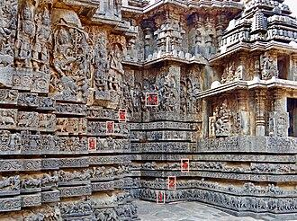
Artwork on the outer walls of the temple are in bands. 1: marching playful elephants; 2: lions; 3: thin miniature scroll; 4: horsemen in different postures; 5: thin miniature scroll; 6: friezes narrating legends from the Hindu texts; 7: makaras; 8: hamsa and peacocks; 9: professionals, daily life of people alternately standing and sitting; 10: mythical creatures, festivals, ceremonies; 11: artha, kama, dharma scenes including courtship and mithuna (eroticism, sex), various occupations, some mythical scenes; 12: large image panels (deities, spiritual stories from Hindu texts).
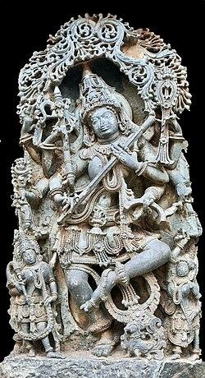
Dancing Saraswati holding a manuscript, pen, the alapini vina and other symbols of knowledge and arts.
The temple outer walls is intricately carved. Its lowest layers consist of bands with friezes that consist of (from bottom to top) elephants, lions, scrolls with nature and miniature dancers, horses, scrolls, scenes from Hindu texts mythical beasts (makara) and swans. According to Shadakshari Settar, the artwork shows details as "no two lions are alike in the entire span that covers more than a furlong (200 metres)", the artists "captured the Ramayana and the Mahabharata, and the main episodes of the Bhagavata". The temple's outer wall is a pictorial narration of Hindu epics, and its middle portion has large panels where "the entire pantheon of Hindu divinities are presented, it is a manual of Hindu iconography", states Settar.According to Foekema and other art historians, the quality and quantity of the epics-related "friezes are amazing", but the panel series do not complete the story in a stretch, rather after a stretch, another text is intermingled in for a while.The outer walls of the Hoysaleswara temple shrines feature 340 large reliefs.
The friezes and wall images on the outer wall predominantly narrate the Ramayana, the Mahabharata, the Bhagavata Purana, the other major Shaiva and Vaishnava Puranas. Some main displays include (clockwise):
- On the north-east outer wall of the northern Shiva temple: Court scene, Bhairava, Bharavi, Samudra manthan, musicians with 12th century musical instruments, Sukracharya, Kacha-Devayani legend, Lakshmi, Umamahesvara, Vamana-Bali-Trivikrama legend, Indra legend, Virabhadra, Shiva in yoga.
- On the south-east outer wall of the northern Shiva temple: Dancers, Bhairava, Bhairavi, Umamahesvara.
- On the north-east outer wall of the southern Shiva temple: Krishna's lila from Bhagavata, Vasudeva in prison followed by carrying newborn Krishna across Yamuna legend, Krishna slaying Putani and other asuri, Krishna stealing butter, Krishna playing flute with humans and animals dancing, Krishna and Pradyumna legend, Krishna lifts the goverdhana, Yudhisthira and Sakuni playing dice, Kichaka molests Draupadi and Bhima meets Kichaka dressed up as a woman to return justice.
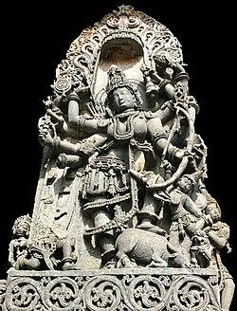
Durga as Mahishasuramardini killing buffalo demon.
- On the south-east outer wall of the southern Shiva temple: Bhisma parva and Drona parva of the Mahabharata; Vishnu standing, dancers and musicians celebrating the victory of Arjuna over Drona.On the south-west outer wall of the southern Shiva temple: Arjuna with Krishna episodes in the Mahabharata; dancers festively celebrating the victory of Pandavas; the Mohini legends in the Vedas; Dakshinamurti, Umamahesvara, Tandavesvara, Vishnu; Arjuna meets Shiva legends; Aranya parva of the Mahabharata; Bhima and Bhagadatta legend; Bhairava, Ganesha, Vishnu and Vamana; Dancers and musicians at the marriage of Parvati and Shiva; Vishnu-Shiva-Brahma together; Shanmukha and Tarakasura legend; Tandavesvara; three face Brahma on a swan; Shiva with Ganesha and Kartikeya; Narasimha doing yoga; Durga as Mahishasuramardini; Mohini dancing.
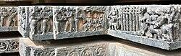
A Ramayana frieze, outer wall.
- On the north-west outer wall of the southern Shiva temple: Reclining Vishnu with all gods and goddesses in reverence; Prahlada-Hiranyakasipu-Narasimha legend from the Bhagavata Purana; Mohini as Bhairavi with Bhairava; Rama fighting Ravana from the Ramayana; Indra seated; Brahma with Saraswati; Karna-Arjuna and Bhina-Dussasana legends from the Mahabharata; Umamaheshvara, Ganesha; a kissing scene between a man and woman; musicians, dancers; Mohini stories; more courtship and kissing scenes; Kali Shakti legends; Arjuna legends.
- On the south-west outer wall of the northern Shiva temple: standing images of Brahma, Shiva, Vishnu, Durga, Saraswati, Kama and Rati, Parvati, Indrakila legend; Parvati doing yoga; Shiva is infatuated by Mohini; Ramayana stories including the golden deer, the first meeting with Hanuman and Sugriva, Rama shooting an arrow through seven palms, Hanuman giving Rama's ring to Sita; Mohini legends; reclining Vishnu on Sesha giving birth to the cosmic cycle; Vamana legend; avatars of Vishnu; Shiva and Ganesha dancing together; twelve Adityas from the Vedas; Arjuna-Bhisma legends; Shiva and Vishnu's female avatar Mohini dancing together.
- On the north-west outer wall of the northern Shiva temple: Nataraja in Tandava dance; Durga and the Saptamatrika; legends of Abhimanyu, Drona, Krishna with Arjuna in Mahabharata; Nataraja; eight forms of Rudra; Mohini dancing; Bharavi; Sarasvati dancing, Shiva and Ganesha dancing, angry Narasimha, various forms of Vishnu, dancing Ganesha with Gajasuramardana Shiva; Kartikeya; Parvati; dancers and musicians.
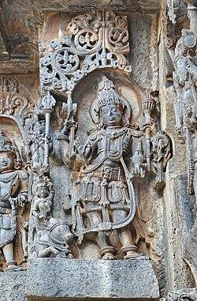
Harihara (left half Shiva, right Vishnu) at Hoysaleshwara
In terms of theology from different Hindu traditions, the large images on the outer walls of the west side present the following frequencies (excluding small panels and miniature friezes):
- Shiva: as Umamahesvara (8), as Nataraja and destroyer of various demons (25), Dakshinamurti (1), as nude Bhairava (6)
- Shakti: as Parvati forms of Durga, Mahishasuramardini, Kali and others (18)
- Vishnu: seated or standing (15), Krishna as Venogopala (12), Varaha (2), Narasimha (4), Vamana (1), Trivikrama (1)
- Harihara (half Vishnu, Half Shiva) (1)
- Ganesha: seated or standing (4)
- Kartikeya: on peacock (1), under seven-hooded serpent (2)
- Brahma (4)
- Saraswati: seated or standing (9)
- Vedic deities: Indra, Surya and others (4)
- Others: Vishnu in his female avatar Mohini clothed and nude, Shiva with Mohini, Arjuna and others (not counted)
The walls on the other side have more large images.
Doorways and mantapa
The temple has four entrances. The one normally used by visitors as main entry nowadays is the northern entrance closest to the parking lot. There is one entry on the south side and two on the east side, facing two large detached open pavilions whose ceiling is supported by lathe turned pillars.
The temple originally had an open navaranga, wherein the mandapa pavilions were visible from outside shrines and the outside was visible to those in the mandapa. In the era of Hoysala king Narasimha I, the mantapa was closed, doors were added and perforated stone screens placed, according to an inscription found in the temple. Along with the four doors, the later artists added dvarapalas and decorations as follows:
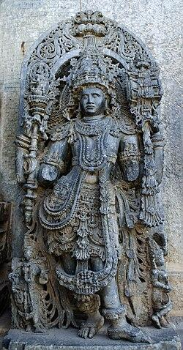
A better preserved dvarapala at mantapa entrance (hands broken).
- Southern entrance: six feet high dvarapalas wearing jewelry on both sides of the doorway. Each has four hands (two broken, others damaged), wear jatamakuta, have third eye and fangs, and stand in S-shaped tribhanga pose. They hold Shiva icons such as damaru, cobra, trisula and others. They were defaced at some point. Attempts were made in the 20th century to trim, restore and re-polish the dvarapala faces, but it created a disproportionate artificial look. Above the door lintel, there is artwork showing a Nataraja (Tandava) along with Nandi, other dancers and musicians.
- Southeastern entrance: similar to southern entrance, two hands broken but the faces are better preserved. Above the door lintel, the carving is the best preserved entrance Nataraja with ten hands (one damaged), accompanied on left by Narasimha, Saraswati, Brahma, Ganesha, Parvati, one deity damaged and unclear and Shiva, while the right side has Shiva, Parvati, Bhairava, Indrani, Keshava, Surya and Parvati.
- Northeastern entrance: the doorway is damaged and dvarapalas are missing though the pedestal and panels remain. The carvings above the door lintel are defaced.
- Northern entrance: used by modern-day tourists. The original dvarapalas are lost, and two replacement mispaired dvarapalas were recovered from the ruins of the region for tourists. The scene above the door lintel is also damaged and inferior in execution.
Outside the southern doorway, in the park, are large statues, one of Ganesha. The statue was among those which were originally farther out at the temple premises outer gate, but damaged and collected from ruins there. They were recovered and placed close to the temple. The navaranga includes two small niches facing each other between the two temples where they are joined at the transept. These have carvings and artwork, but the statues inside each is missing. There is a stone panel near the western niche with a large Sanskrit inscription in a North Indian and a South Indian script.
Pillars and ceilings
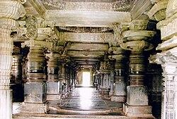
Lathe turned pillars in mantapa of Hoysaleshwara temple in Halebidu
The interior walls of the temple are quite plain compared to the outer wall, except for the lathe turned pillars that run in rows between the north and south entrances.The four pillars in front of each shrine are the most ornate and the only ones that have the madanika sculptures in their pillar brackets.
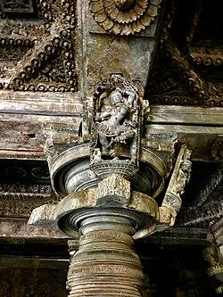
Pillar and ceiling carvings with a damaged madanakai.
The fused mandapa features a row of pillars aligned along the north-west axis. In the central navaranga of each temple's mandapa are four pillars and a raised ceiling that is intricately carved. Each of the four pillars of this central navaranga had four standing madanakai (Salabhanjika, mostly female) figures, or a total of 16 standing figures per temple. Of the 32 figures on the central pillars for the two temples, 11 remain. Only 6 damaged ones have survived in the north temple and 5 in the south temple. A closer examination of the pillar's capital suggests that there was a figure on each pillar in the eastern row facing the sunrise, but all of these show signs of destruction and none of those images have survived. The pillar near the second eastern door have two damaged madanakai, but the better preserved are those in the central navaranga.
Sanctum
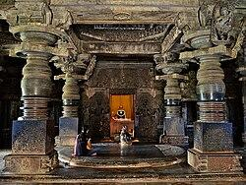
A sanctum inside the Hoysaleshwara temple in Halebidu
The twin-temple has two sanctums (garbha griha), both with Shiva linga. One sanctum is dedicated to "Hoysaleswara" Shiva (the king) and the other for "Shantaleswara" Shiva (the queen, Shantala). Both are of equal size. Each sanctum is a square with a darsana dvara (view doorway) on the east, with three inches on the north, west and south. The doorways are flanked on each side by a dvarapala, each leading to a sukanasi (vestibule chamber). There is intricate carving above the lintel between the dvarapalas, presenting Shiva with Parvati, along with other devas and devis, as well as two large makaras (mythical syncretic sea creatures). On the makaras are Varuna and his wife Varuni riding. The doorjambs are decorated with purnaghatas (vessels of abundance). The sanctum square originally had a tower (shikhara) above rising towards the sky to complete the vimana superstructure, but the towers have been lost to history and the temple looks flat. The sanctum walls are plain, avoiding distraction to the devotee and focussing the attention of the visitor at the spiritual symbol.
The temple has smaller shrines with its own sanctum. For example, the Nandi shrines feature a Nandi in its sanctum, while the Surya shrine features the Hindu Sun god.
Maize-like muktaphala objects
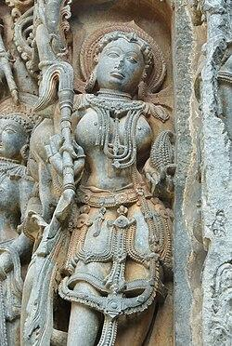
Attendant on Halebid outer wall holding maize-like muktaphala object
Geographers Carl L. Johannessen and Anne Z. Parker identify distinctive objects held by several figures at Hoysala temples, including those at Halebid, Somnathpur and Belur, as maize ears. They argue, controversially, that since maize is a New World crop that could only have been brought across the sea by humans, these sculptures are evidence of pre-Columbian contacts between India and the Americas.
Plant geneticists M.M. Payak and J.K.S. Sachan deny that these sculptures depict maize ears. Instead, they report that local archaeologists identify the objects as muktaphala (literally pearl-fruit), and that they interpret this as an imaginary fruit made of pearls. According to the Wisdom Library online Sanskrit dictionary, muktaphala can refer to a pearl per se, the custard apple, lavali (the west India gooseberry), a flower that occurs in Buddhist literature, or camphor, but it makes no mention of an imaginary fruit made of pearls.
Ethnobotanist and Indologist Shakti M. Gupta concurs with Johannessen and Parker that the objects in question are maize ears:
Different varieties of the corn cob [Zea mays Linn.] are extensively sculpted [...] on the Hindu and Jain temples of Karnataka. Various deities are shown as carrying a corn cob in their hands as on the Chenna Kesava temple, Belur. The straight rows of the corn grains can easily be identified. In the Lakshmi Narasimha temple, Nuggehalli, the eight-armed dancing Vishnu in his female form of Mohini is holding a corn cob in one of her left hands and the other hands hold the usual emblems of Vishnu. [...]
Temples where the corn cobs are found are dated 12-13th century A.D. [...] By the time these temples were constructed, maize would have been fairly common in India.
Artists
Numerous temple artwork panels contain signatures or statements by the artists or the guild they belonged to, and these are usually at the artwork's pedestal or underneath. The most repeated names of artists found at the Hoysaleswara temple include Manibalaki, Mabala, Ballana, Bochana, Ketana, Bama, Balaki and Revoja. The guilds can be identified by the organization's icon marked and names inscribed such as Agni-Indra, Indra, Paduca (.west) and Paduvala-badaga (.northwest).
The Hoysaleshwara Temple, a 12th-century UNESCO World Heritage Site, is located in the town of Halebidu within the Hassan District of Karnataka, India. As a pinnacle of Hoysala architecture, its geographic positioning, local topography, and geological material heavily influenced its construction and historical prominence.
Geographic Location & Regional Setting
- Macro Location: Situated in South India, in the south-western part of the Deccan Plateau within the state of Karnataka.
- Micro Location: Nestled in Halebidu, which was historically known as Dorasamudra (or Dwarasamudra). The town served as the illustrious capital of the Hoysala Empire.
- Surrounding Landscape: The region transitions between the semi-arid plains of eastern Karnataka and the forested hills of the Western Ghats (Malnad region), providing a strategic geographic stronghold during the medieval era.
Topography & Hydrology
- The Dorasamudra Lake: The temple was deliberately built on the banks of a vast, man-made reservoir or artificial lake known as Dorasamudra. The name itself is derived from the Sanskrit words Dwara (gateway) and Samudra (ocean or large body of water).
- Water Engineering: The proximity to the reservoir served both religious and utilitarian purposes. It supplied water to the temple complex, maintained a cooler local microclimate around the stone structures, and acted as a foundational element of the city's broader defensive network.
Geological Material (Soapstone Geography)
- Chloritic Schist (Soapstone): The temple's geography is intimately tied to its geological resources. The master craftsmen quarryed chloritic schist, commonly known as soapstone, from the surrounding regional terrain.
- Sculptural Advantage: This specific metamorphic rock is prized for its unique physical properties. It is relatively soft when freshly quarried, allowing sculptors to execute microscopic, deep-undercut carvings with absolute precision. Over time, exposure to the atmosphere causes the stone to harden, ensuring the longevity of its intricate horizontal friezes.
Spatial Layout & Orientation
- East-Facing Alignment: In accordance with Hindu architectural geography, the twin shrines—one dedicated to Hoysaleswara (representing the masculine aspect/King Vishnuvardhana) and the other to Shantaleswara (representing the feminine aspect/Queen Shantala Devi)—both face directly east to greet the morning sun.
- The Jagati Platform: The entire twin-shrine complex rests on a massive, elevated, star-shaped platform (jagati). This layout mirrors the undulating topography and serves a dual purpose: it raises the temple above potential flood levels from the adjacent lake and provides an expansive, open-air path for ritual circumambulation (pradakshina).
Nearby Heritage Geography
The geography of Hoysala sacred spaces forms a close network within the Hassan district. When visiting Halebidu, you are positioned near several other critical historical nodes:
- Belur (Chennakeshava Temple): Located roughly 16 kilometres away, it was the original Hoysala capital before it shifted to Halebidu.
- Kedareshwara Temple: A smaller, highly detailed contemporary temple situated within walking distance along the same historical road in Halebidu.
- Jain Basadi Complex: Located just a few hundred metres away, featuring ancient step wells and monolithic statues, reflecting the pluralistic religious geography of the medieval capital.
Destroyed parts
1. The Superstructure Towers (Vimanas/Shikharas)
- The Entirely Missing Roof Towers: Originally, the twin main shrines of Hoysaleswara and Shantaleswara featured soaring, intricate star-shaped towers (Vimanas or Shikharas) typical of Hoysala architecture.
- The Flat-Roofed Appearance: These superstructure towers were completely demolished during the invasions. Today, the temple has a noticeably flat roofline, leaving it fundamentally altered from its original silhouette.
2. Defaced Exterior Reliefs and Wall Sculptures
- Chipped and Broken Idols: The outer walls of the temple host a massive, continuous gallery of over 240 large deities. Raiders deliberately targeted these statues. Many of the larger wall reliefs depicting Vishnu, Shiva, Brahma, and the Goddess Durga feature sheared-off noses, broken limbs, severed hands, and shattered attributes (like weapons or musical instruments).
- Mutilated Friezes: The lower bands of horizontal carvings—which meticulously depict elephants, horses, and narrative scenes from the Ramayana, Mahabharata, and Bhagavata Purana—show varying degrees of chipping and blunt-force damage, intentionally aimed at desecrating the religious narratives.
3. The Garbhagriha (Sanctum Sanctorum) Deities
- Lost Principal Idols: While the sacred stone Shiva Lingams inside the dual sanctums survived and are worshipped today, other accompanying wall iconography, door guardians (Dvarapalas), and decorative entrance lintels within the inner corridors were smashed or heavily defaced.
4. Broken Madanikas (Bracket Figures)
- Missing Dancers: Originally, the angled pillars supporting the outer eaves of the temple featured dozens of highly polished, under-cut sculptures of celestial nymphs or dancers (Madanikas or Shilabalikas). While a few breath-taking examples survived, many were violently ripped from their sockets or broken down into fragments.
5. Outer Complex and Surrounding Capital Ruins
- The Lost Surrounding Temples: The Hoysaleshwara complex was once part of a sprawling royal and sacred precinct featuring dozens of smaller temples. Most of these adjacent structures were flattened into mounds of stone rubble.
- The Royal Palace: The grand Hoysala Palace, which stood immediately west of the temple complex, was entirely burnt down and destroyed, leaving nothing behind but archaeological fragments and mounds of earth near Benne Gudda.
Reason of destruction
The primary reason for the destruction of the Hoysaleshwara Temple was the geopolitical expansion and wealth plundering by the Delhi Sultanate during the early 14th century.
As the Sultanate pushed south to expand its empire and empty the treasuries of southern kingdoms, the Hoysala capital of Dorasamudra (modern-day Halebidu) became a prime target due to its immense wealth.
The destruction occurred in two catastrophic waves:
1. The First Raid by Malik Kafur (1311 CE)
- The Target: General Malik Kafur, acting under the orders of Sultan Alauddin Khilji, led a massive military expedition into South India.
- The Motive: The campaign was driven by a desire to seize gold, jewels, horses, and elephants to fund the Sultanate's military machine back in Delhi.
- The Outcome: The Hoysala King, Veera Ballala III, was caught off guard, defeated, and forced to surrender his immense wealth. The invading army thoroughly plundered the capital's royal palaces and stripped the Hoysaleshwara temple complex of its gold, silver, and precious gemstones.
2. The Second Raid and Complete Sack (1326 CE)
- The Target: Just fifteen years later, the armies of the Delhi Sultanate returned under Sultan Muhammad bin Tughlaq.
- The Motive: This second invasion was less about a quick raid and more about absolute conquest, territorial submission, and breaking the socio-religious spine of the local kingdom.
- The Destruction: During this raid, the capital city was completely sacked, burnt, and reduced to ruins. The grand superstructure towers (shikharas) of the Hoysaleshwara temple were cast down, and many of its intricate external sculptures were intentionally defaced or broken.
Reference videos:
https://youtu.be/ekkpGm_F7Wo?si=VPXip5zqXvAMNKkV
Summary: This video provides a direct, comprehensive overview of the temple's structural layout and composition. It details how the twin temples are built on a symmetrical square plan and face east, representing the masculine and feminine aspects of divine energy.
Highlights: It highlights the unique geography of its materials—explaining how the artisans used soft soapstone (chloritic schist) that was easy to carve initially but hardened over centuries of atmospheric exposure. It also walks viewers through the Pradakshina Patha (circumambulation platform) where thousands of continuous friezes narrate the Ramayana and Mahabharata.
Halebidu Hoysalesvara Temple UNESCO World Heritage wth guide Hassan Karnataka Hoysala Temple Tourism
- Summary: A travel-oriented historical guide that connects the temple to its surrounding geographic elements and past devastation. It explicitly covers how the temple sits adjacent to the massive, man-made Dorasamudra lake and describes the competitive nature of its construction against the Chennakeshava Temple in Belur.
- Highlights: This video delves deeply into the 14th-century invasions by the Delhi Sultanate. It summarizes how the capital was looted twice, explaining that while the robust soapstone foundations survived, the grand superstructure towers (shikharas) were cast down, leaving the temple with its modern flat-roofed silhouette. It also features the massive, richly decorated monolithic Nandi shrines and the adjacent 7-foot tall Surya statue.
Belur & Halebeedu | UNESCO World Heritage sites
Summary: This guide acts as a regional comparative documentary, linking the geography of Halebidu directly with its sister city, Belur. It focuses on the sheer timeline of Hoysala craftsmanship and the architectural marvels left behind.
Highlights: The video showcases the intricate internal mechanics of the temples, focusing on the highly polished, lathe-turned pillars. It also discusses the architectural engineering of the era—such as gravity-defying pillars and miniature stone carvings—providing context on why these temples are universally celebrated as the peak of medieval South Indian art.

Effect of climate on the temple
1. Heavy monsoon rainfall
Rainwater repeatedly comes into contact with the temple's soapstone (chloritic schist) surfaces. Over long periods, this contributes to weathering and erosion of exposed architectural details.
2. Moisture and humidity
High humidity during the monsoon can encourage moss, algae and lichen growth, particularly in shaded or poorly drained areas. This can gradually affect the stone surface.
3. Temperature changes
Seasonal heating and cooling cause small expansions and contractions in the stone. Repeated cycles can contribute to surface deterioration over centuries.
4. Drainage and water accumulation
The temple's detailed carvings and horizontal surfaces can retain moisture. Proper drainage is therefore important for protecting the sculptures and foundations.
5. Vegetation
The warm and wet climate supports vegetation around the monument. Roots growing close to masonry can potentially contribute to cracking or displacement if not controlled.

Special cuisines of Halebidu
- Bisi Bele Bath – A popular Karnataka dish made with rice, lentils, vegetables and spices.
- Ragi Mudde – Finger-millet balls traditionally eaten with sambar, saaru or vegetable curries.
- Akki Roti – Rice-flour flatbread, often served with chutney or vegetable curry.
- Kadubu – A traditional steamed or boiled dumpling made from rice or millet; both sweet and savoury varieties are found in Karnataka.
- Mysore Pak – A famous Karnataka sweet prepared from gram flour, ghee and sugar.
- Dharwad Peda – A milk-based sweet associated with Karnataka.
- Thatte Idli – Soft, flat steamed rice-and-lentil cakes, commonly eaten with chutney and sambar.
- Karnataka-style Jolada Rotti – Sorghum flatbread, usually accompanied by spicy vegetable preparations.

FAQ – Hoysaleshwara Temple, Halebidu

1. Where is Hoysaleshwara Temple located?
It is located in Halebidu, Hassan district, Karnataka, India.

2. Who built Hoysaleshwara Temple?
The temple was built during the Hoysala period, mainly under King Vishnuvardhana, in the 12th century.

3. Which deity is worshipped in the temple?
The temple is dedicated to Lord Shiva, worshipped as Hoysaleshwara.

4. When was the temple built?
Construction began around the 12th century, approximately in the 1120s CE, and continued for several decades.

5. What is the temple famous for?
It is famous for its intricate soapstone carvings, detailed sculptures, friezes, pillars and remarkable Hoysala architectural design.

6. What type of stone was used?
The temple was primarily constructed using soapstone (chloritic schist), which allowed craftsmen to create extremely detailed carvings.

7. What is special about its architecture?
The temple has a distinctive Hoysala architectural style, including a star-like plan, richly decorated exterior walls, multiple sculptural bands and finely carved pillars.

8. Why are some parts of the temple damaged?
Damage occurred over centuries due to historical conflicts, weathering, natural deterioration and exposure to the environment. Some sculptures and architectural elements are incomplete or damaged.

9. How does the climate affect the temple?
The monsoon rainfall, humidity and biological growth can contribute to weathering of the stone and deterioration of exposed carvings.

10. What food is famous around Halebidu?
Traditional Karnataka foods such as ragi mudde, akki roti, bisi bele bath, kadubu and Karnataka-style sweets are commonly associated with the region.

11. Why is Hoysaleshwara Temple important today?
It is an important example of medieval South Indian architecture and Hoysala craftsmanship and is part of the Sacred Ensembles of the Hoysalas, a UNESCO World Heritage Site.

12. What makes the sculptures unique?

The sculptures depict Hindu deities, mythological stories, animals, dancers, musicians and scenes from everyday life, showing the exceptional skill of Hoysala artisans.

